Development Diary
Day 1:
Created a new project using ASP.NET core web App (Model-View-Controller), this gives me a slid foundation to work off of and properly create a good solution for the client.
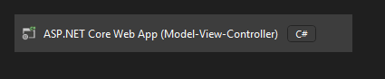
I selected .NET 9.0 frame work as it is the most stable at the moment. I also selected individual accounts as the solution does require individual accounts to meet the standards of the client. Individual accounts being my authentication type gives me an application with an already working and secure account registration system implemented and I need to add little alterations to it to fit my needs, improving efficiency and security of the site.
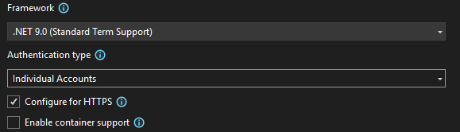
Next I created my models
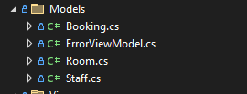

I then scaffolded my models out with views and controllers. By keeping the models, views and controllers in their own folders I am promoting organization and maintainability, mitigating the chance of the project getting unorganized.
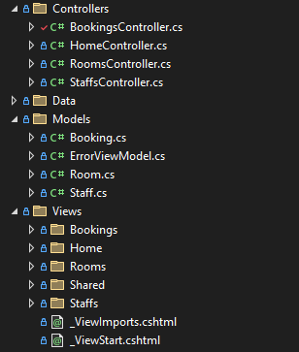
Then added my first migration, called it “InitialCreate” as this is industry standard and updated my database.
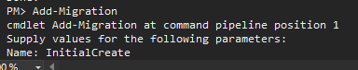
Next I got to work with adding my google authentication. This gives users the ability to log into the solution using their google log in information, making it quicker and easier as a user wouldn’t have to make a new password and it also makes their account easily accessible to them. I did this by registering my solution in google cloud console, making the credentials and giving it my solutions URL to redirect to. Then I implemented the code into the solution
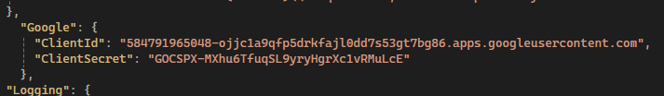
and updated my program.cs file
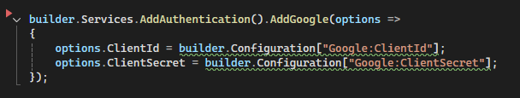
Meaning users could now login using their google account.
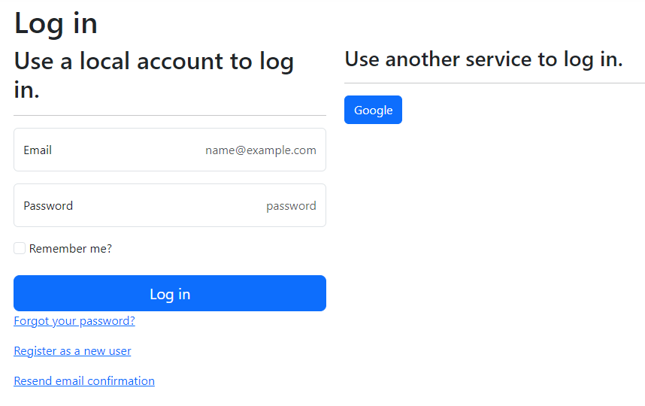
I then created seed data of roles for staff and customer, creating demo accounts so they can be logged in to for testing purposes, tweaked the rooms and bookings controllers to only show the needed columns in the front end, and removed them from the “bind” so it doesn’t cause problems later on, scaffolded out the “Identity” folder so I could add users that have just logged in through google as customers (customers role) this helps later down the line as without this they will remain a default user and wouldn’t be able to see any of the pages that have been secured. It would be as if they had never logged in.
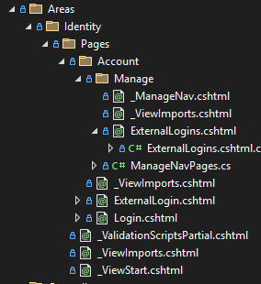
I then added authorization to the controllers to make sure only authorized users could view them using industry standard authorization, non-logged in users can’t see past the home page, users cant see other users bookings but only theirs. and staff members can see all bookings that have been created, and edit or delete them. Securing the website fully.
Today i:
- Created my Solution
- Added models, controllers and views to the solution
- Added the ability for users to log in using their Google accounts
- Added authorization to the solution, securing the website.
- Added staff and customer roles and auto assigned customer roles on login through google.
Tomorrow I want to:
- Make the bookings system fully functional
- Add the ability for staff to approve or deny bookings
- Give customers to ability to properly create a booking
- Seed staff into the staff page and add styles to display them properly
- Seed bookings and rooms

Day 2:
Today I started by seeding data for rooms and bookings.
I realised that I had made a mistake in my bookings controller, calling UserId as an integer value instead of a string, and also calling “RoomsId” instead of “RoomId” meaning I had to restart my solution.
When attempting to fix this I thought both foreign keys would need to be string values so I changed both to string leading to more issues meaning I had to restart my solution again.

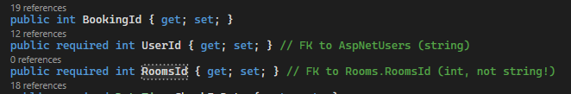
After fixing this I then seeded rooms and bookings properly and tested the authorization I added yesterday for staff and customers to be able to see certain aspects of the pages.
(staff view)
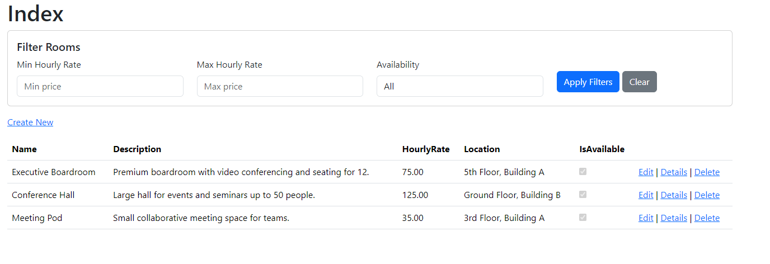
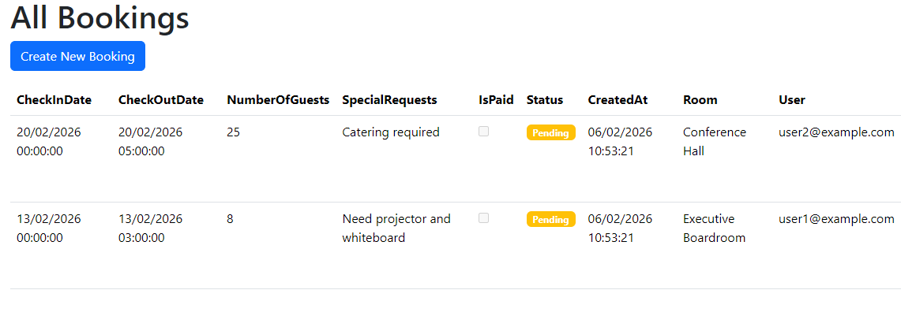
I also ran into an issue where bookings couldn’t be manually created but showed when seeded. I then resolved this issue and it had something to do with the UserId not being linked to the newly created booking.
Tomorrow I want to:
- Create the function for staff members to be able to approve or deny bookings
- Allow users to be able to start a booking from the Rooms page
- Seed staff members and create staff dashboard

Day 3:
Today I added the functionality for staff members to be able to approve or deny bookings, I also added extra security so bookings can no longer be edited by the staff or the customer when the booking has been approved or denied
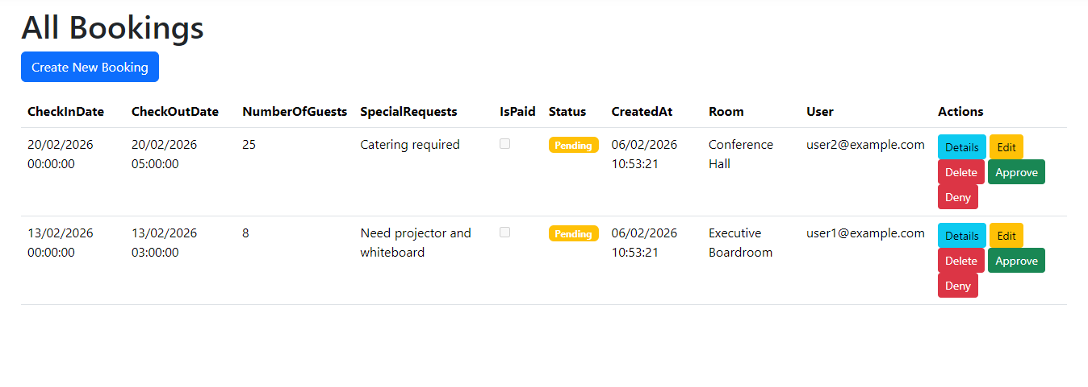

Day 4:
I also updated my authorization for my rooms controller as you could view the rooms index when not logged in. I added a “book now” button for each of the rooms and it redirects to the Bookings create page.
While testing the login functions and roles I found out that customer roles had the create edit and delete buttons on the rooms page
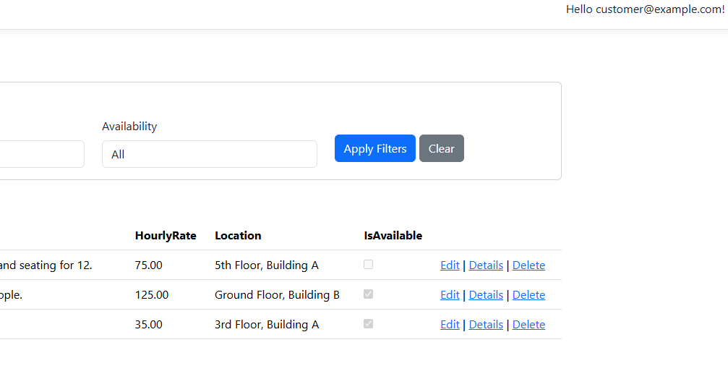
Although it denied access to the pages I still had to fix this as they shouldn’t know that it is possible in the first place.
This was a css issue not checking the users roles while displaying the buttons, fixed by adding checks.

found out that filter by price crashes the solution when only one of the 2 inputs are entered.
This is cause because the system was checking if minimum price was input but then filtering by the maximum price, by changing the variable the system then is allowed to check even if the other input is null.
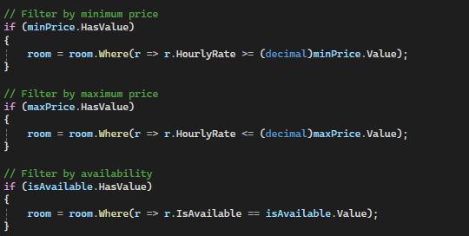
Today I also properly styled all
(staff view)
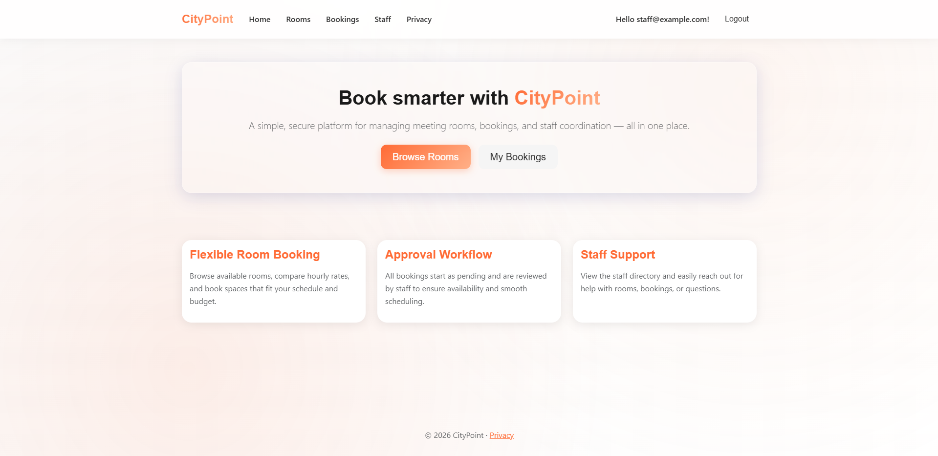
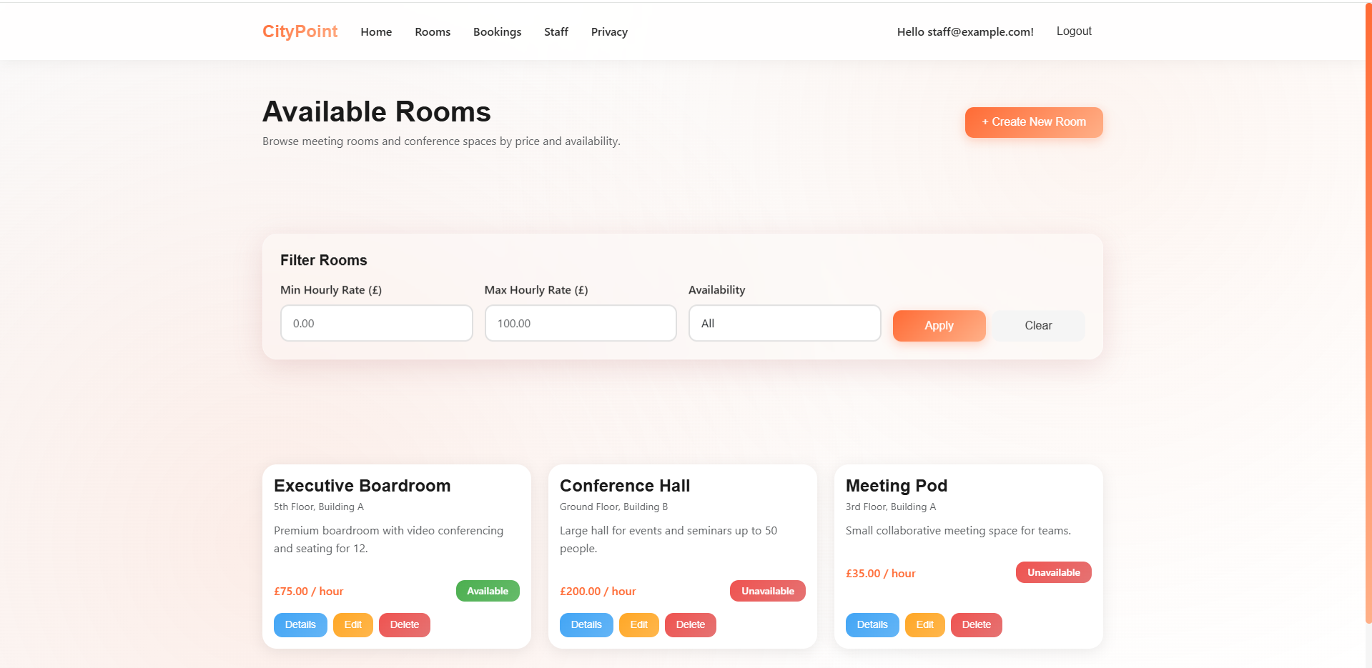
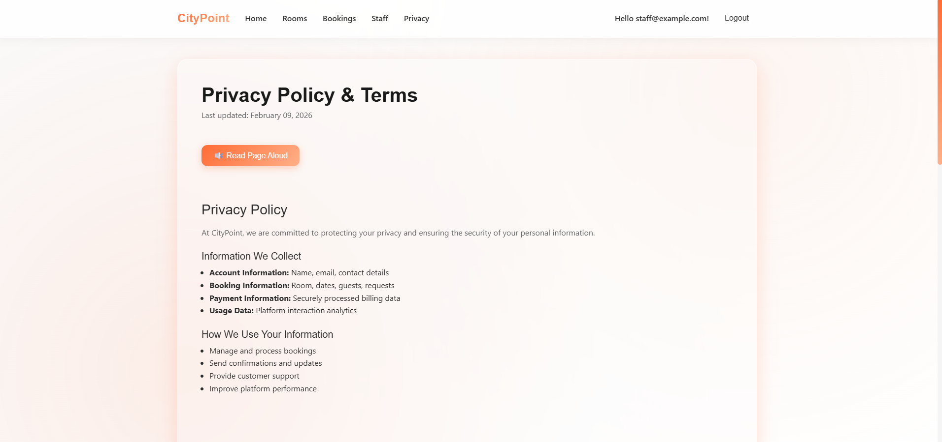
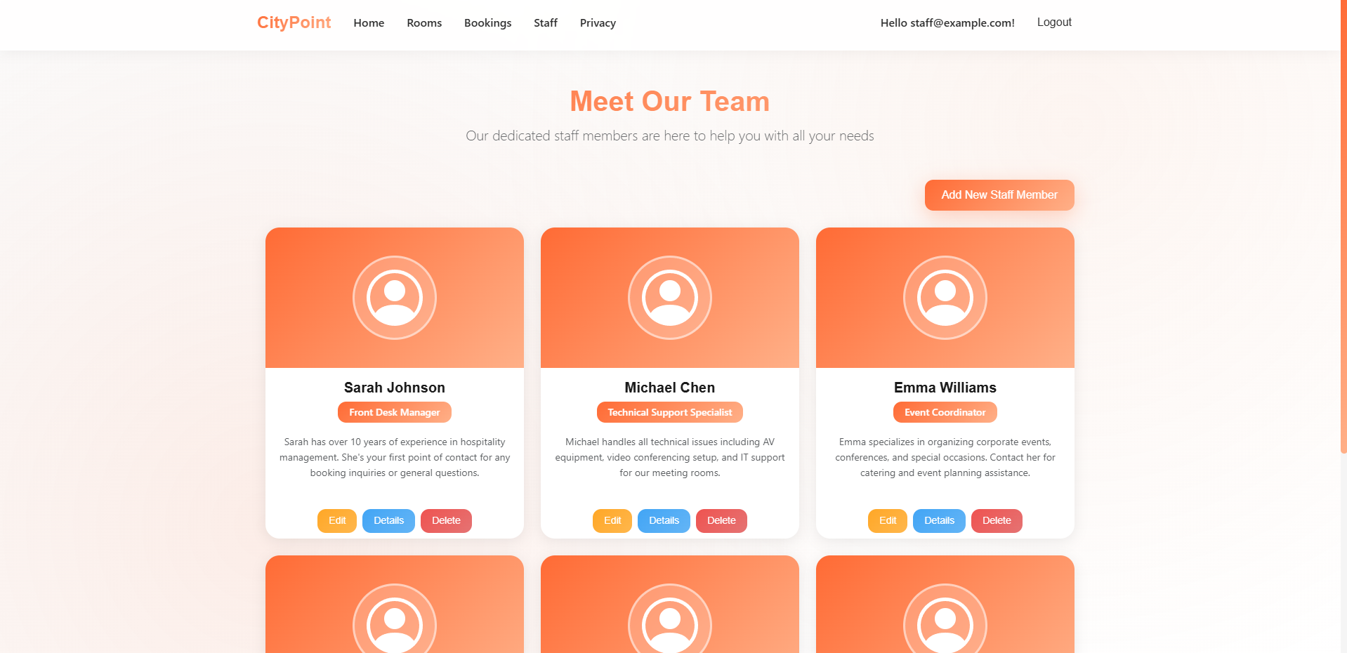
Also attempted to add Text to speech functionality but it wasn’t working and wasn’t sure how to fix it (no red lines in js or view)
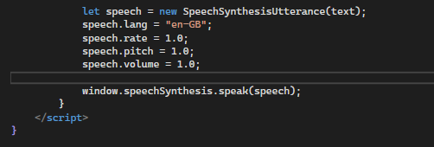
Fully commented all code
Day 5:
I attempted adding accessibility settings using javascript but couldn’t get them to work so excluded them from the website
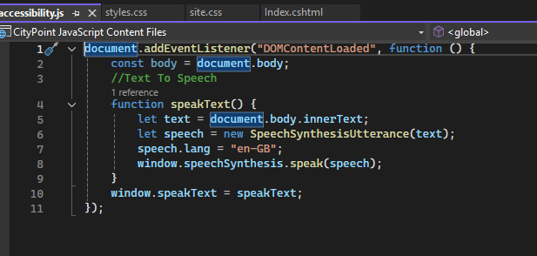
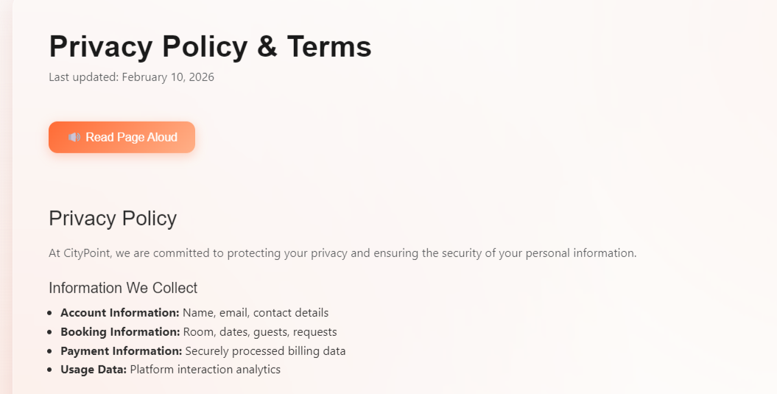
Today I took a showcase video for my website for submission.
Fixed an authorisation error where non-logged in users could view the rooms tab.
Fixed an issue where availability filter for bookings was broken as the “isavailable” variable was omitted.
Fixed an issue with bookings not posting because I seeded rooms as not available so the seed bookingas couldn’t pick the rooms to create a booking as they were “unavailable”
Added prompts to AI log
completed Source log

